Chapter 13, Problem 21.

Using Fig. 13.90, design a problem to help other students to better understand energy in a coupled circuit.
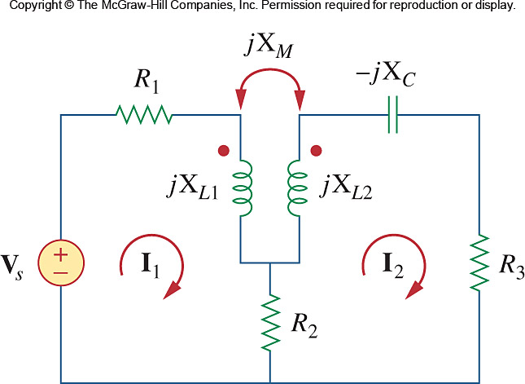

Figure 13.90
For Problem 13.21.

